# How to deploy a react app on GitHub Pages.

We will start by installing the github desktop for the installation not only of the software but also the commands we are going to need for deployment on github.

So apparently git does not come with github pages, don’t know what this is due to. So instead I went to download git software for bash (<https://git-scm.com/download/win>). With this you can now go ahead and use the git commands that enable you to get a react app on github pages.

First of all you have to create a repository on github ( I am following the steps of a video which is <https://www.youtube.com/watch?v=1Y-PqBH-htk&list=PLJ2r5QDc8YOEPOea0Bx0T0lEWGZLP_gt3&index=2&t=0s> in this vid you can see the steps)

This repository has to be called username.github.io and instead of username replace with your github username.

Following step is to create the repository where the react app is going to reside.

Previously create a react project to continue to the next step.

And now for the fun part, the bash:  
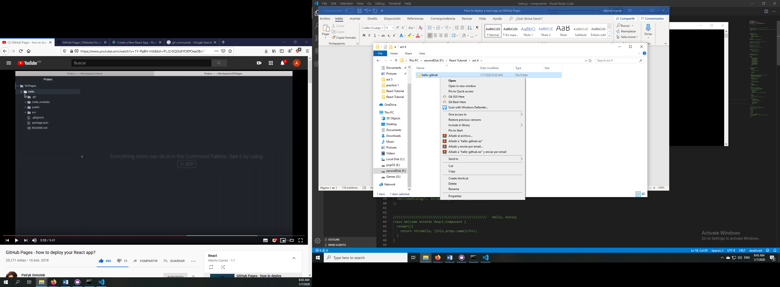

After you install git you will now see a new option when you right click a folder.

We then click open with git bash here

And follow the steps that are given in your first glance of the repository that you have previously created (where the react app is going to reside)

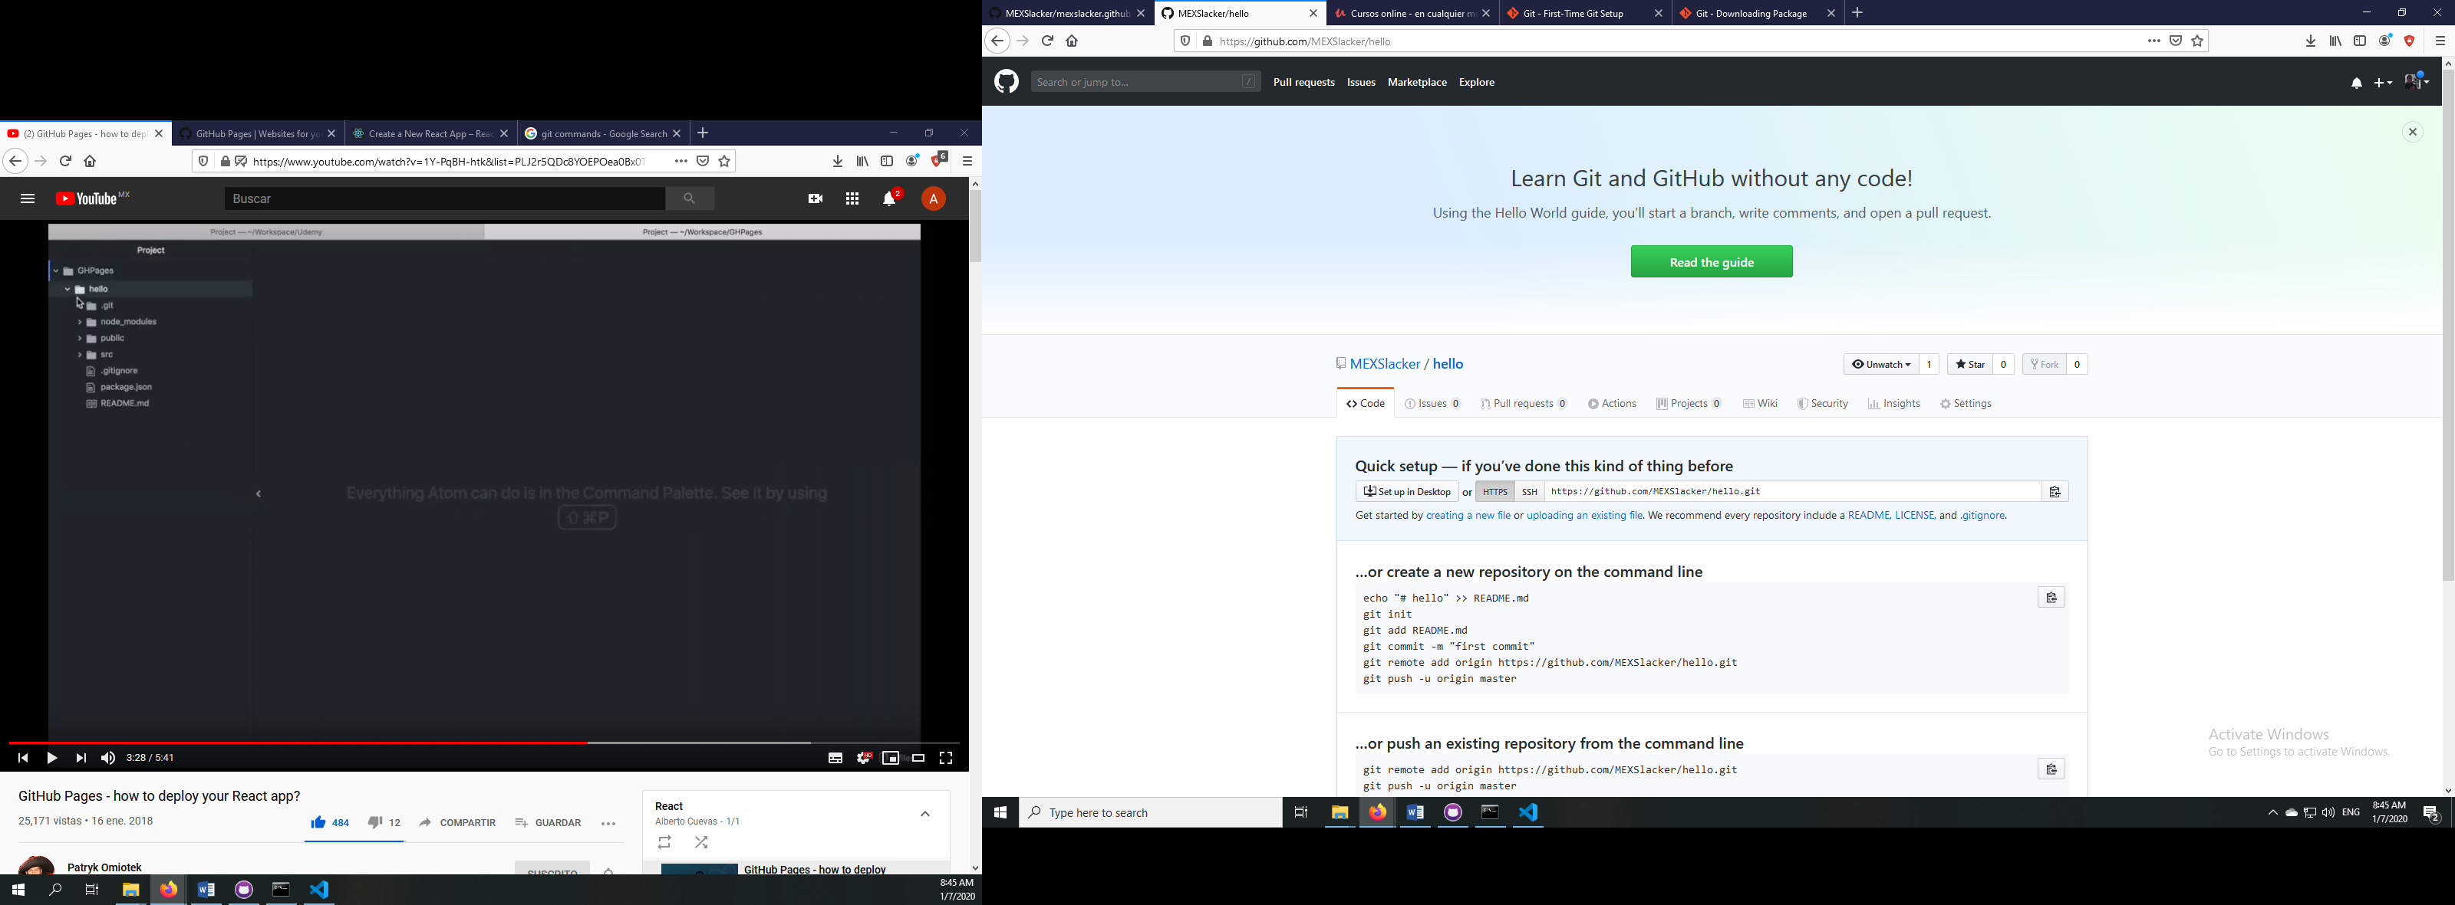

So after this we have to make some changes in the file package.json and add the following commands

“homepage”: <https://username.github.io/name-of-project>,

“predeploy”: “npm run build”,

“deploy”: “gh-pages -d build”,

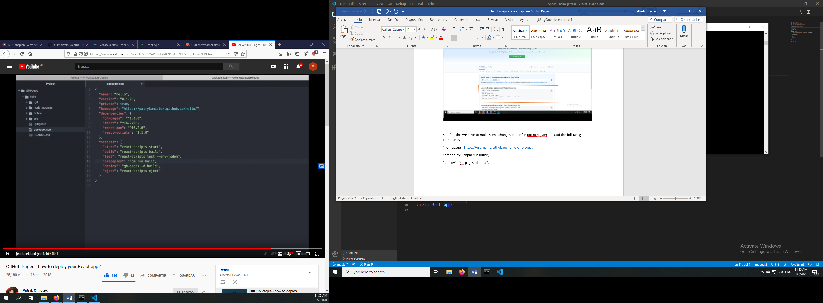

Now we try to deploy it to GitHub by running the command npm run deploy

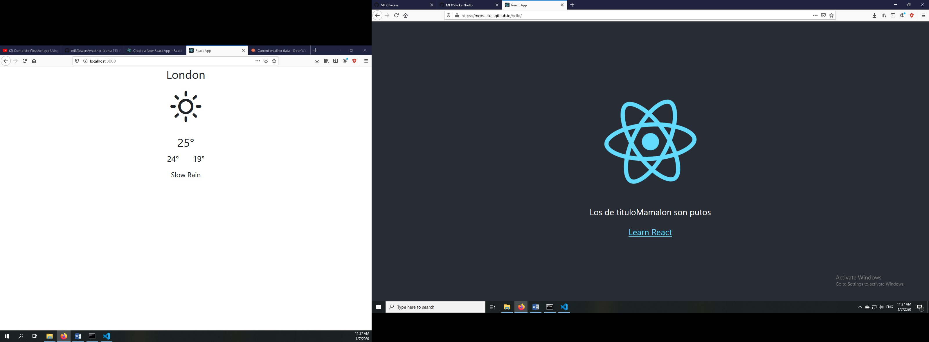

this is the page that I have uploaded to my GitHub profile.